# Tutorial 2.3

Part (1) simulated the LIF model with an adaptation current so that the full model:

[Codes for part (1)](https://drive.google.com/file/d/1G4s5K4Wl9KZOoRvTBwSTgrsA-MumVttc/view?usp=drive_link)

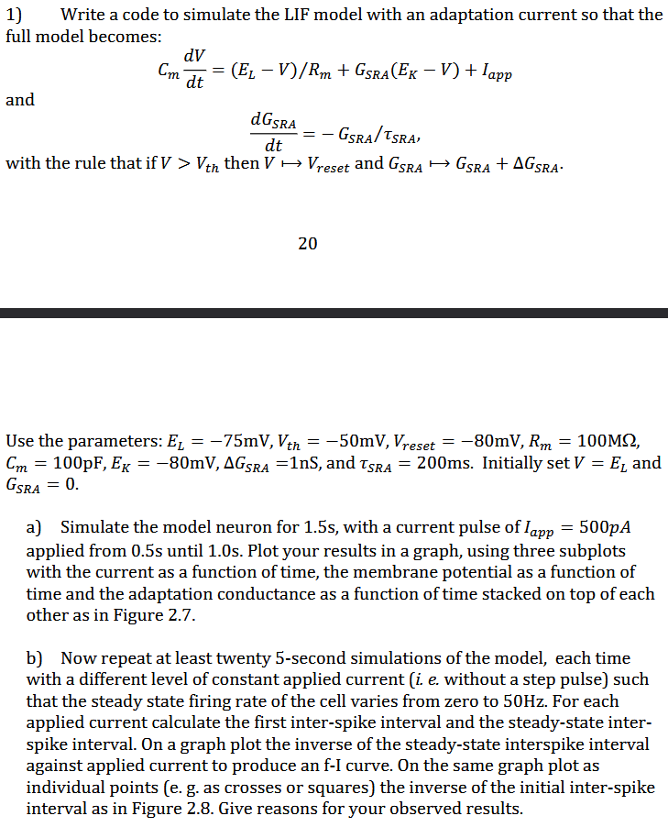



1. Simulated the LIF model neuron for 1.5s, with a current pulse of Iapp​=500 pA applied 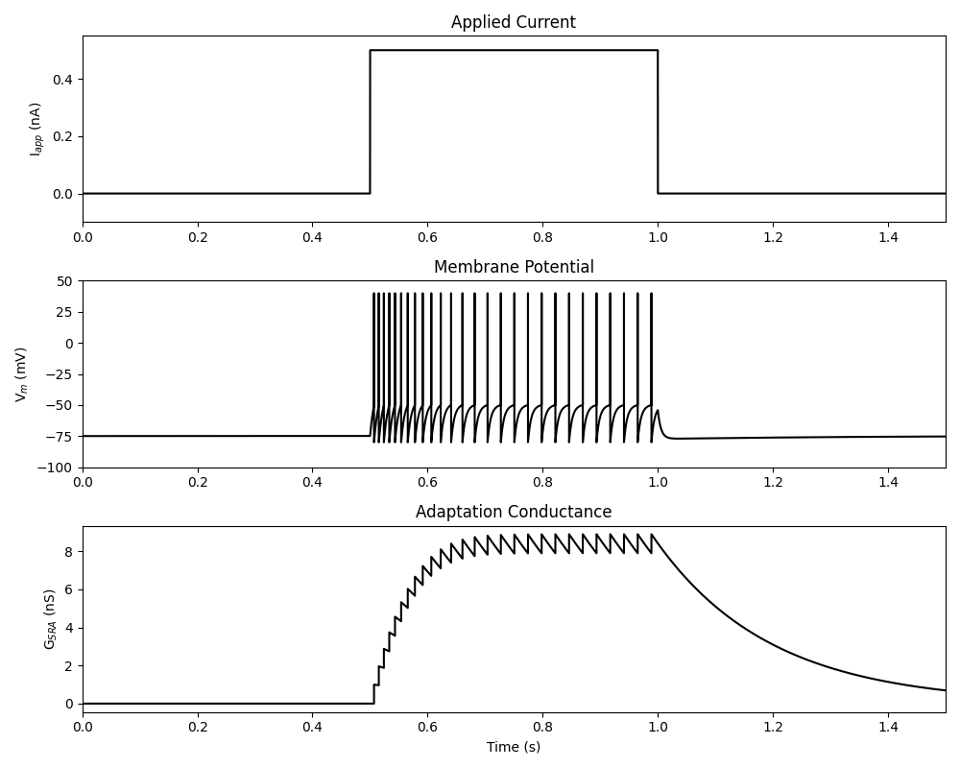from 0.5s until 1.0s. (See line 1 - 76)
2. Repeated twenty 5-second simulations of the model, each time with a different level of constant applied current (0.2 - 0.35 nA). (See line 79 -141)
   * Plotted the inverse of the steady-state inter-spike interval against applied current to produce an **f-I curve**.
   * Plotted individual points as crosses representing the inverse of the initial inter-spike interval. 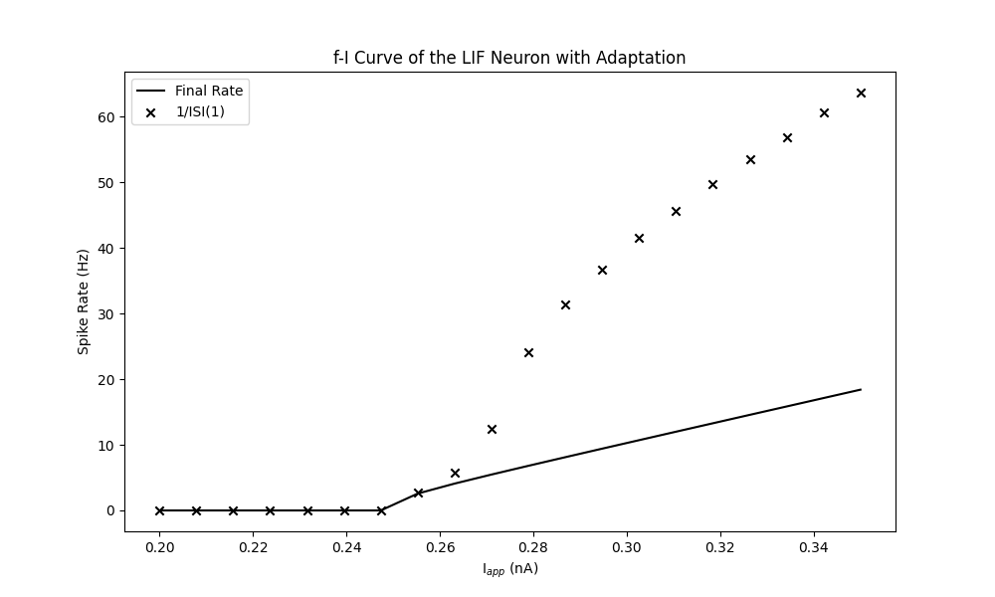

By applying current during 0.5s to 1.0s, inter spikes occur respectively in the period. Looking at the membrane potential versus time graph, the Vm is equal each time. It could be caused by the absence of adaptation recovery and strength values in the LIF model. The adaptation conductance increases as the current applies and reaches a plateau in 0.1s, the peaks are aligned with those in membrane potentials.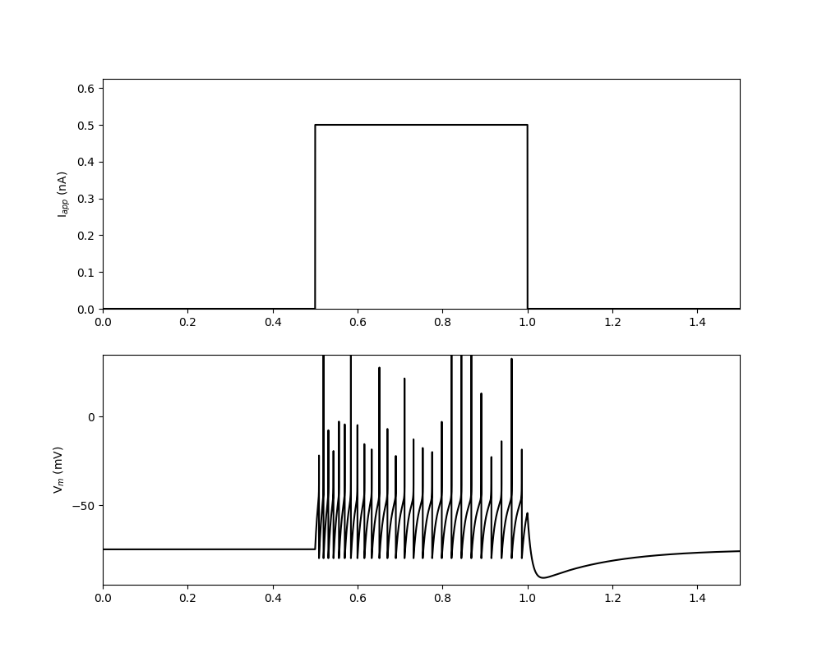

The points of the initial spike interval show a higher value and larger slope than the line of the steady state spike interval. This could be implied by the first graphs where the time interval of spikes shows a declination over time. The function of the model tells the reason that the increasing rate of the membrane potential is inversely proportional to itself.

Part (2) Simulated the AELIF model: [Codes for part (2)](https://drive.google.com/file/d/11M3IJIbhzFRhv6N_F2gAEZvLWjQMyFNZ/view?usp=drive_link)

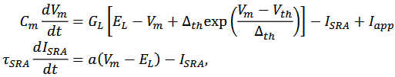With required parameters.

1. Simulated the LIF model neuron for 1.5s, with a current pulse of Iapp​=500 pA applied from 0.5s until 1.0s. Two required subplots included: applied current v.s. Time and membrane potential v.s. time (See line 1 - 77)
2. Repeated twenty 5-second simulations of the AELIF model, each time with a different level of constant applied current (0.2 - 0.375 nA). (See line 80 -161)
   1. Plotted the inverse of the steady-state inter-spike interval against applied current to produce an **f-I curve**.
   2. Plotted individual points as crosses representing the inverse of the initial inter-spike interval.

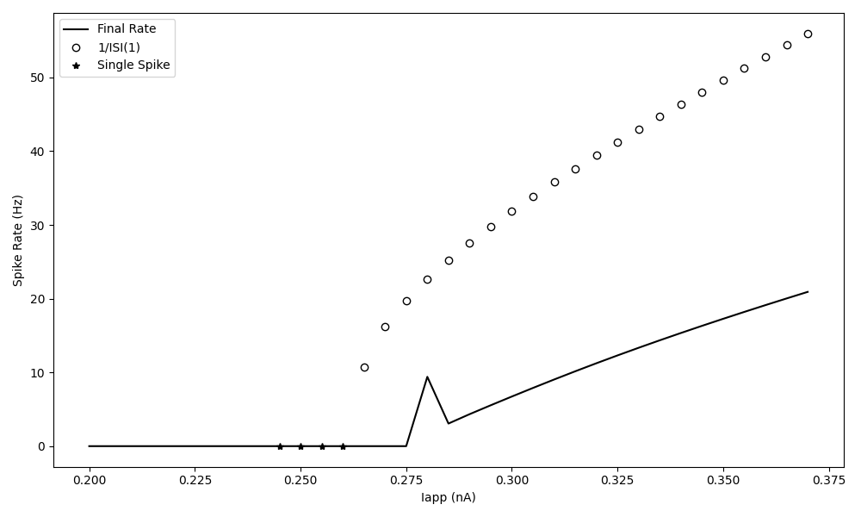

In comparison to the results from part a, the main difference is the dynamics in the membrane potentials of spikes. This is caused by the property of the AELIF model. It contains an extra exponential term for smoother threshold onset, also there are variables taking adaptation strength into account.

I would say the general trends of the spike rate graphs are similar in both models, except for a peak of the steady state spike rate around 0.28 nA.By plotting V curves with single applied current, I did not find an abnormality or rapid increase in the spikes rate. It could presumably be the function did not recognize correctly the interval of the steady states.